OOP – Lab
BSCS [2-A]

FINAL TERM PROJECT
CONSOLE BASE SOCIAL MEDIA APPLICATION

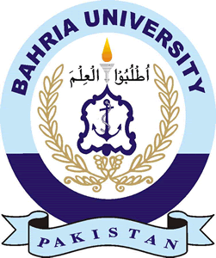
DEPARTMENT OF COMPUTER SCIENCES
BAHRIA UNIVERSITY, LAHORE CAMPUS

Submitted By

- M USMAN MALIK (Leader)
- M ASHIR AMIR
- M MARIS HAMZAH
- M ZOHAIB INAM

Submitted to: Mr. Rizwan Khalid

Project Outcome
